

WEB Technology

Course Project Report



October 8, 2021

Team 7

Public Grievance Forum



Web Technology Course Project Report

By:

* Raghavendra A Hallyal - 01fe19bcs304
* N.V Nagananda - 01fe19bcs284
* Sanjay Bhat - 01fe19bcs283
* Chirag Tandel - 01fe19bcs280

Under the Guidance of:

* Prof. Manjula Pawar

Problem Statement:

Design a Public Grievance registration platform where:

* Citizens can register the complaint to Government officials by providing details.
* Registered complaint must be redirected to respective department.
* Officials can view the complaint and update the status by writing the actions initiated/taken.

Framework Chosen:

* Node.Js with HTML and CSS

Methodology Used:

* Created a Login Page where Citizens can Register an account with Email and Password.
* Department officials and the Head Official can Login to their respective portals with the credentials provided in the Database.
* Registered Citizens can lodge a complaint with setting the time slot they are available by logging in to their account and an OTP is generated with each complaint
* Status of the lodged complaint can be seen by the Citizen who registered the complaint as well as the Head Officer(overseer), who can then assign that particular complaint to the respective department official.
* The department official who the complaint is assigned to will have to enter the OTP generated with the complaint (which is only visible to the Citizen who had lodged that complaint) as a proof of complaint resolution.
* The Citizen can also rate the service provided by the Department Official.
* Head Officer can see all the pending and completed complaints.

Database Design:

There are 6 tables:

* To store information of Head Officer
* To store information of all the Complaints lodged.
* To store all the information related to feedbacks given to a service for a complaint.
* To store the information of all the registered citizens.
* To store the information of each Department Official.
* To store all the common problems that the public might face.

UI Design:

Login Page

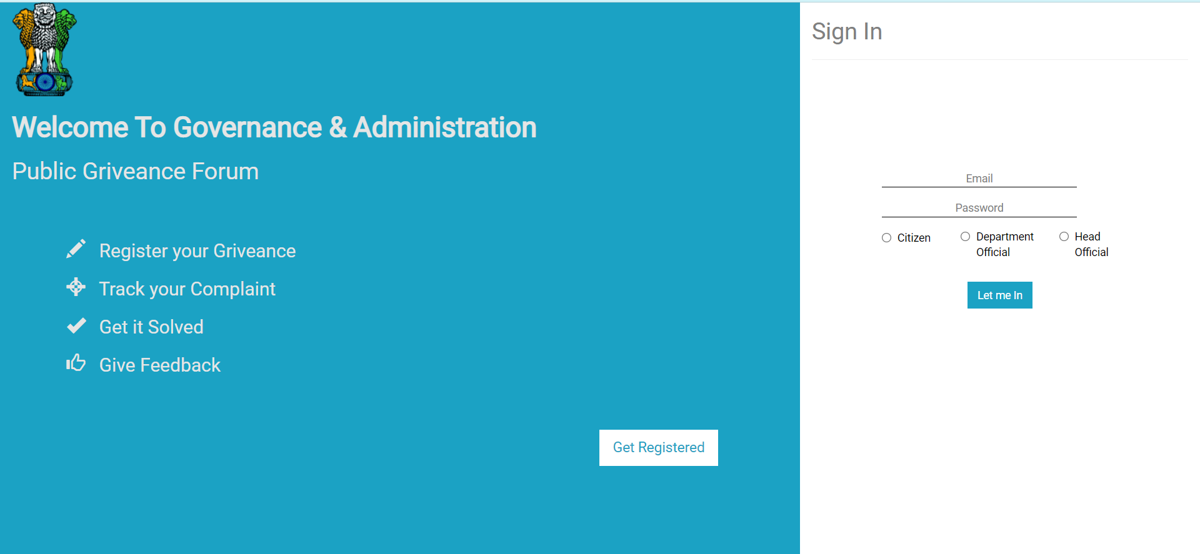

New Citizen Registration:

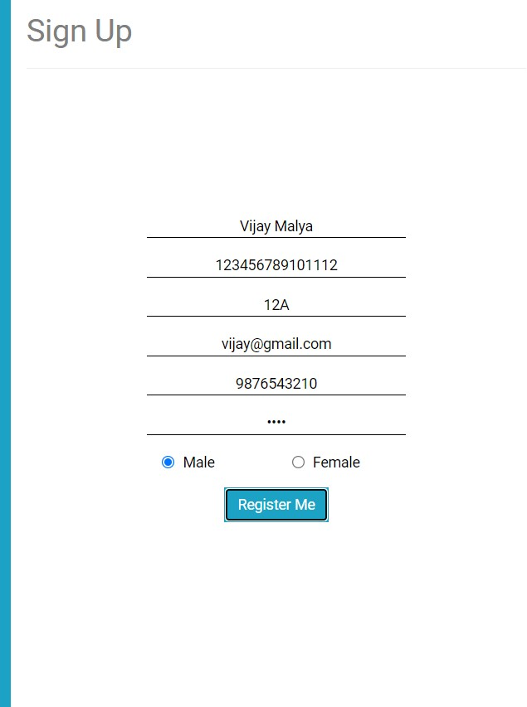

Citizen Info Page

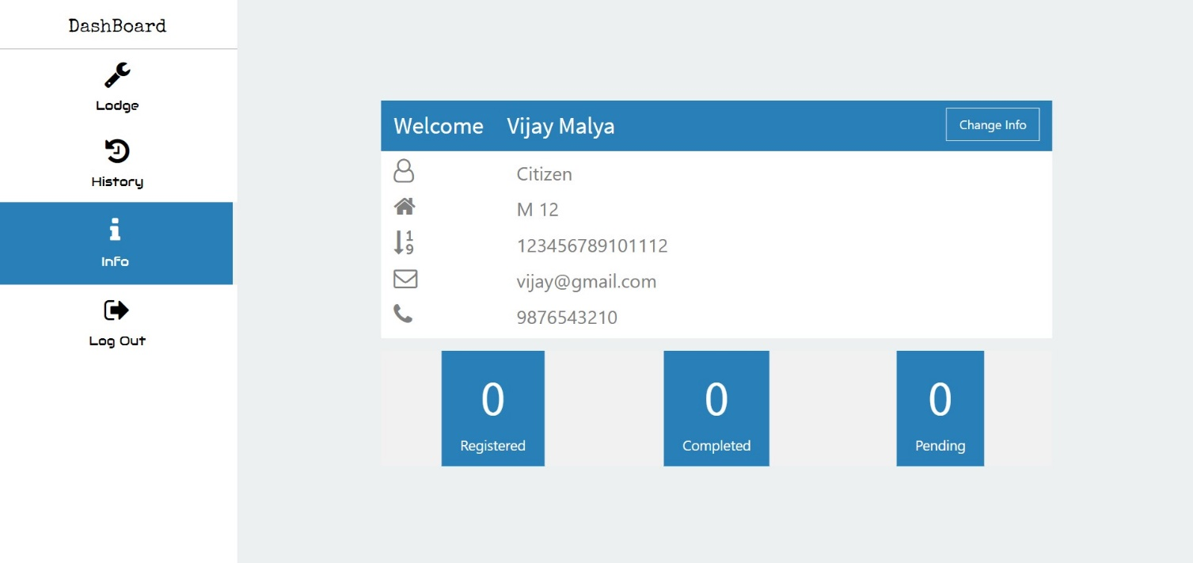

Citizen Lodge Complaint Page

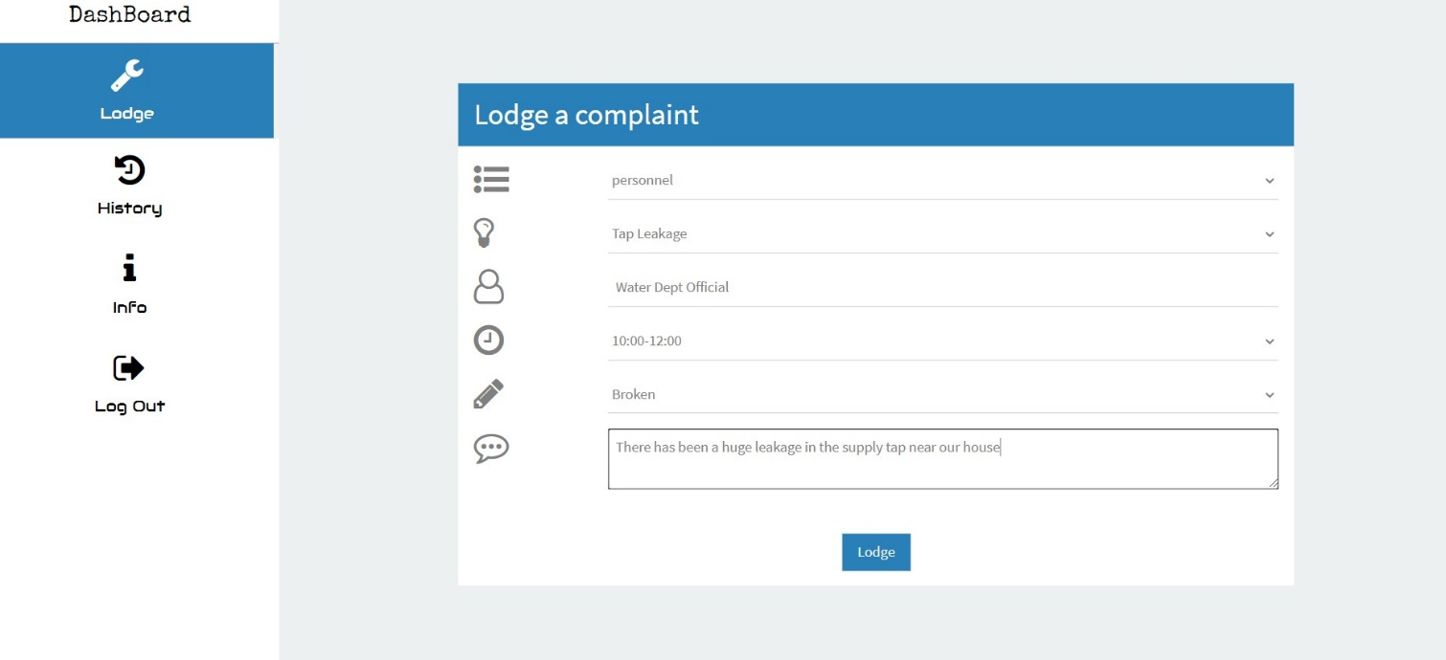

Citizen Complaint History Page:

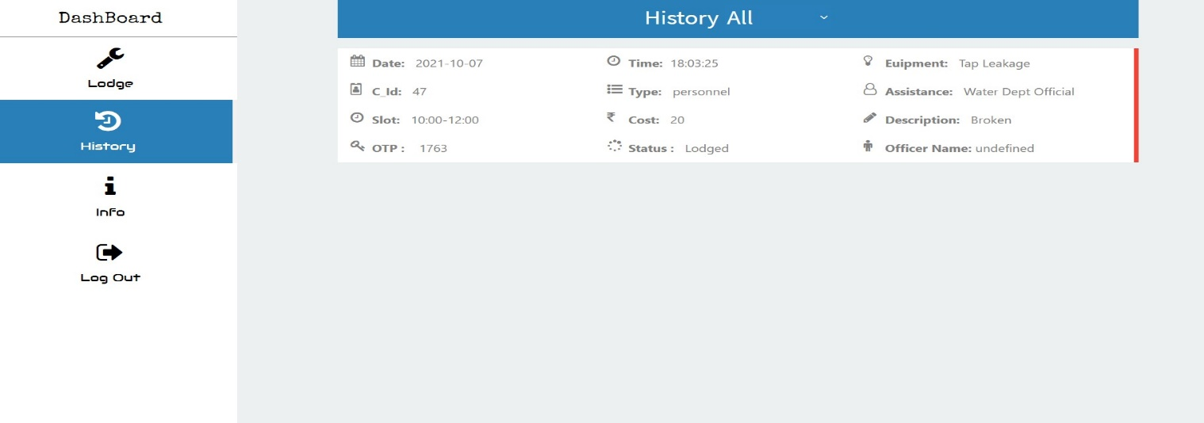

Head Officer Info Page

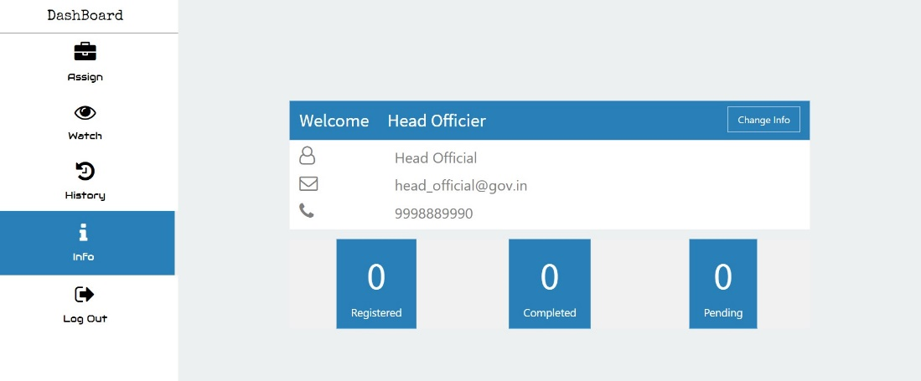

Head Officer Watch Page:

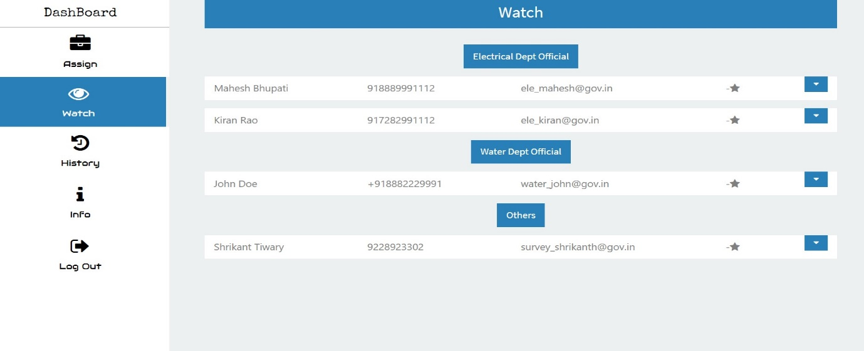

Head Officer Assign Page:

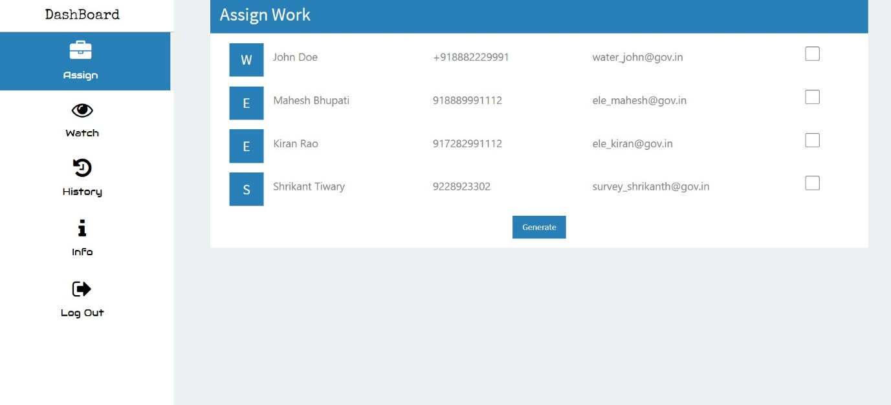Department Officer Info Page

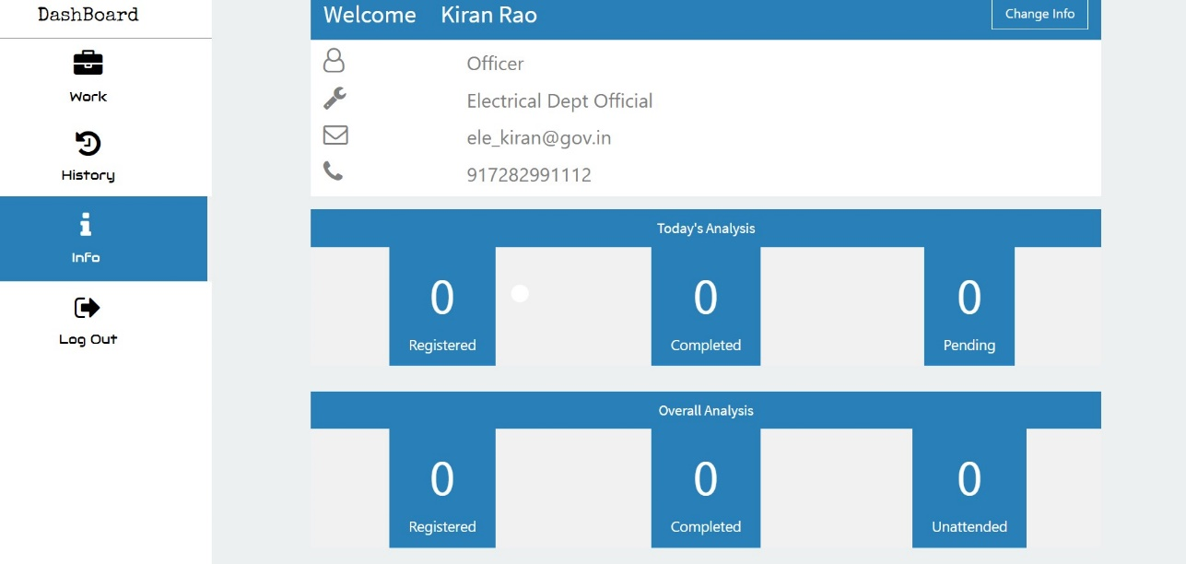

Complaint Resolved Example:

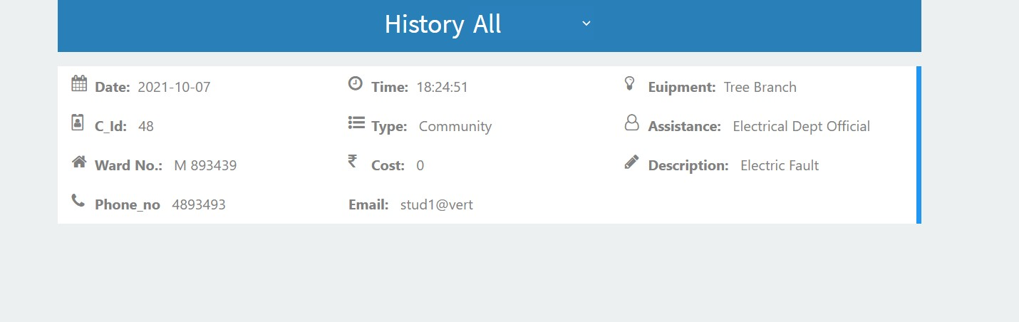

Admin View History of Complaint:

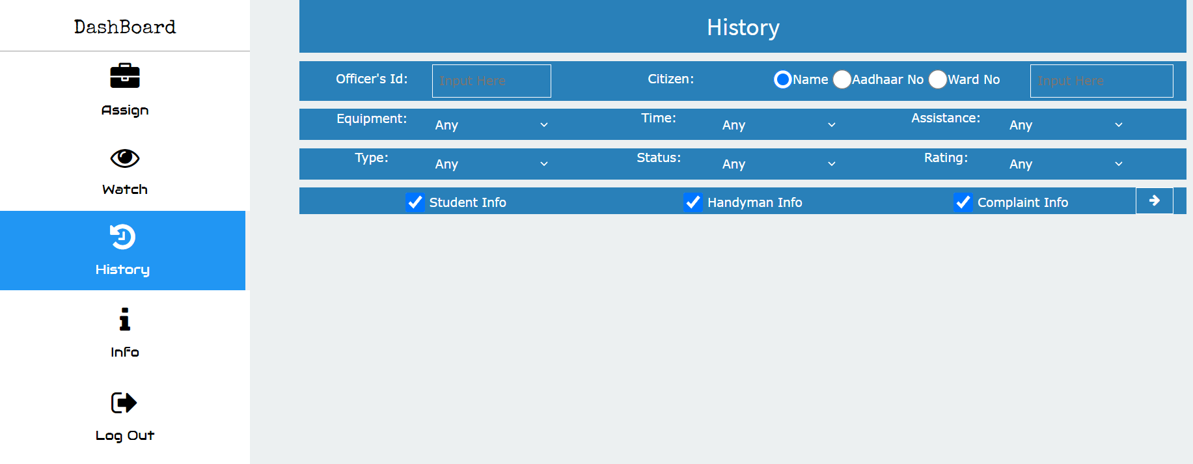

Change Password & Update Phone No of Citizen, Department Officer & Head of Department:

